2017 FDCC Annual Report
This is the ninth annual report for the Foundation for Developing Cambodian Communities Ltd., trading as Cambodian Kids Can (CKC).

What was Achieved in the 2016/17 Year
As a keen supporter of CKC reading this annual report, you should feel extremely satisfied that your very generous donations are being utilised with great effect on the ground in Cambodia.

During this year to June 2017, the year twelve pass rate in Cambodia was a very poor 62%. Incredibly, however, all seven of the Mekhala House year-12 girls passed and were accepted into University on fee-free scholarships. It is wonderful to see such amazing outcomes from the projects supported by CKC in that country.

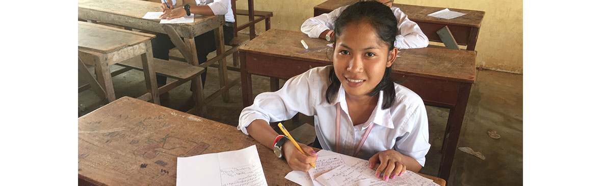

Noy, featured above, was the standout year 12 student, and commenced an accounting degree in Phnom Penh. The other girls are studying various courses such as nursing, sales & marketing, accounting and Khmer Language.

At the end of this 2017 financial year, CKC was supporting;
- One student undertaking a 2-year hospitality course at the best training institute in Phnom Penh
- Eleven students were studying at various universities, mostly in Phnom Penh, and
- A further 41 primary and secondary level students residing at the Mekhala House boarding home in Phnom Penh

With your support, the members and supporters of CKC, the girls at Mekhala House continue to take full advantage of the opportunity that has been presented to them. From a background where early childhood schooling was almost certainly sacrificed due to dire financial necessity,

these girls have shown that when given a chance of a secure upbringing and encouragement to perform well at their studies, they will grab the opportunity with enthusiasm and gratitude.

At Mekhala House, the staff are conscious of the fact that they need to provide a nurturing and caring home environment where the girls can develop into mature, well educated young adults.

For this reason, CKC has recognised that forming relationships with other NGO’s is critical as it provides access to resources and expertise that is not available form within the staffing at Mekhala House. M’Lup Russey s one such partner of CKC, and is a very well resourced NGO with strong social work skills in the residential care arena. As an example, some of the older Mekhala House girls were fortunate enough to attend a workshop in self-development and personal budgeting during the year.

As part of this focus, the young girls approaching the latter stages of their secondary schooling need to be given adequate guidance on career opportunities, and the illustration below shows them attending a workshop conducted by the National Institute of Education in Phnom Penh.

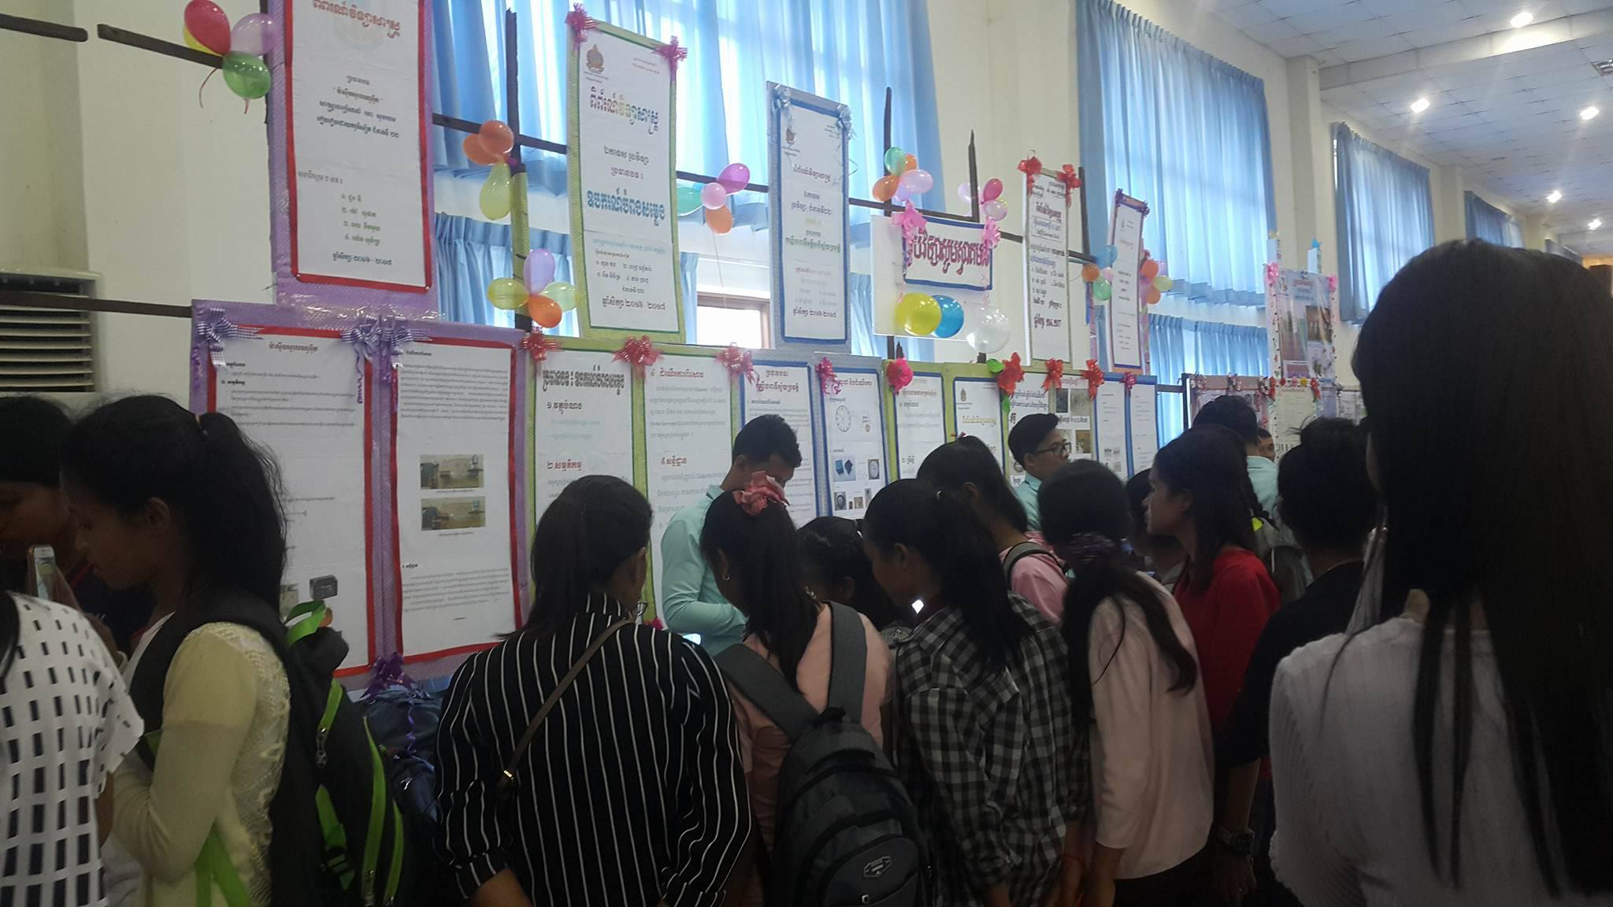

The other major project we operate in Prey Veng is the Mekhala Learning Centre (MLC).

Unlike Mekhala House which focuses on disadvantaged and ‘at risk’ young girls, MLC offers free English, Internet and Computer Studies to disadvantaged members of the broader Prey Veng community, having a mix of young men and women. These students, who are often commencing university courses, gain very practical, hands-on experience with computers. It is very often the first time they have actually touched such hardware and used the associated software; such is the paucity of facilities available at government schools and universities.

In addition to these critical subjects, MLC continues to conduct short courses such as CV Preparation, Job Interviewing skills, and Personal Finances, all of which are invaluable to the attending students.

During this financial year, the tenth semester was conducted and now 483 students have successfully completed the course.

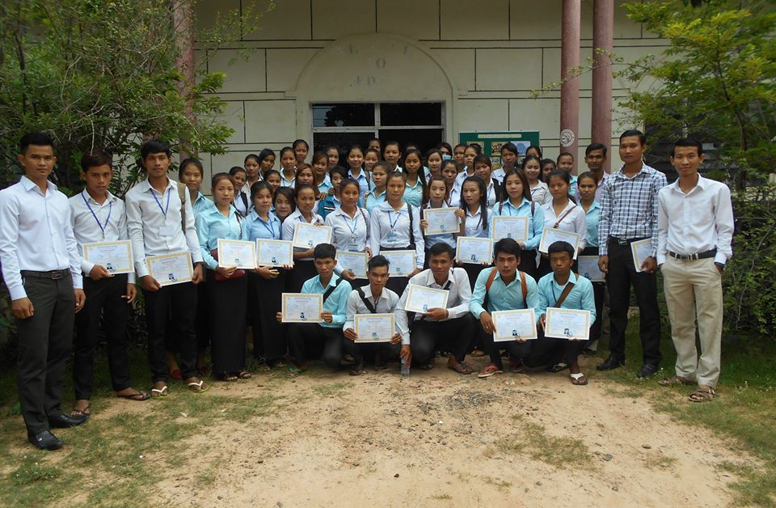

The staff at MLC also work very closely with the National Employment Agency in Prey Veng. The management at this agency recognise the important skills acquired by students completing an MLC course, resulting in very quick take-up by of these students by local businesses such as micro-finance or telecommunications companies as well as government departments in the area.

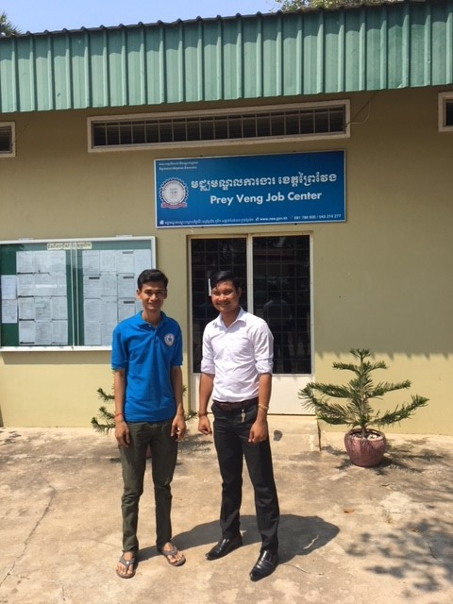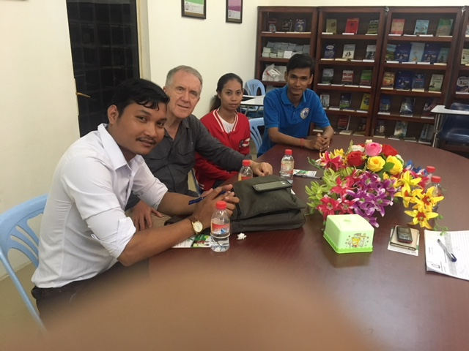

MLC also operates a very well-resourced library, clearly the largest accessible by Prey Veng residents. It is not uncommon for more than 500 visitors to attend the library, reading more than 1,500 books or undertaking internet-based research on the library laptop computers.

CKC Fundraising
Both donations and general fundraising proceeds were quite a bit stronger in this latest fiscal year, lifting by almost $25,000.

However, costs associated with fundraising activities as well as overall Cambodian project expenses were also higher, reflecting the costs of supporting additional young women undertaking tertiary studies, as well as cost escalation as a direct result of weakening of the Australian dollar against the US dollar in which Cambodian expenses are outlaid.

The main sources of income during this fiscal year included another very successful annual dinner, corporate support from Cooper Investors and VAA, as well as stronger revenue from individuals providing specific financial support to university girls.

The Directors would again most sincerely like to acknowledge the wonderful efforts of so many volunteers who organise fundraising events for CKC. These people are too numerous to mention, but a big thank you to everyone who has volunteered their time or donated money to ensure CKC to continue to be able to support the work in Cambodia.

Conclusion

This 2016/17 financial year has seen CKC continue to provide education-based assistance to students from poor families who otherwise would most likely miss out on a comprehensive education opportunity. The beneficiaries from both Mekhala House and MLC continue to express their heartfelt gratitude to CKC supporters, recognising that through their personal development, they will be in a sound position to alleviate the poverty that besets their families in a third world country.

The organisation is particularly indebted to the Directors of both FDCC Cambodia and CKC Australia for making this happen, but especially to all the donors and local volunteers who support us in so many varied ways. With ongoing cooperation between Australia and Cambodia, and with everyone’s’ continued enthusiasm and support, we will continue to develop young women who really will become ‘change agents’ in dragging their impoverished communities slowly out of poverty.

Patrick Arthur
CKC Chairperson

